

普通本科毕业论文（设计）

题 目： | 海外教育学校管理系统
英文题目： | Overseas Education School Management System

学 院 | 计算机与人工智能学院
专 业 | 计算机科学与技术
学生姓名 |  | 学 号
指导老师 | 赖新峰 | 职 称 | 副教授

二〇二三 年 五 月

普通本科毕业论文（设计）原创性声明
题 目 | Overseas Education School Management System
论文形式 |  |  |  | （应与开题报告中所填内容一致）
学 院 | 计算机与人工智能学院 | 专 业 | 计算机科学与技术（留）
指导老师 | 赖新峰 | 职 称 | 副教授
学生姓名 |  | 学 号 |  |  | 班 级 | 19计算机科学与技术（留）
原创性声明

本人声明所呈交的论文是我个人在导师指导下进行的研究工作及取得的研究成果。尽我所知，除了文中特别加以标注和致谢的地方外，论文中不包含其他人已经发表或撰写的研究成果，也不包含为获得江西财经大学或其他教育机构的学位或证书所使用过的材料。与我一同工作的同志对本研究所做的任何贡献均已在论文中作了明确的说明并表示了谢意。

学生签名：

日期：2026年5月15日

ABSTRACT
The Overseas Education School Management System (OESMS) is software meant to help institutions. The school management system aims to collect information from (students, instructors, courses, departments, and enrollments), analyze, and store it to help the administration have absolute control. A school management system is good for the people who facilitates the school and suitable when their kids enroll, and many more. My Overseas Education School Management System (OESMS) is developed to help head of departments, students, departments, and instructors to reduce workload, cut costs, save time, and improve data security. All these things will eventually make the institution more cost-effective and productive. It can also secure essential data of students and educators that every educational institution needs.
The general idea of this project is how to manage Overseas Education School Management System, and School Management System helps head teachers to get the correct data to make more effective and friendly decisions. The head teachers will attain time-saving administrative statistics. The head teachers can get all information from their students, departments, courses, instructors, and when students enroll in the school system.
The Overseas Education School Management System (OESMS) is a Desktop application developed in Java language, JavaFx as Framework and MYSQL as RDBMS (Relational Database Management System) backend.
To put in force My School application, the school does not want high-priced hardware and software; therefore, a desktop is required. Our machine works as a centralized database and utility that the school can use without difficulty and get entry to the system from the computer laptop primarily based on the login credentials. My school uses a desktop platform system that only head teachers can access without internet. Overseas Education School Management System, is customized for individual school needs.

【Key words】: Overseas Education School Management System; Data security; MYSQL; Effective; JavaFx

Table of Contents
Chapter 1 Introduction 1
1.1 Background 1
1.2 Problem Statement 1
1.3 Motivation 2
1.4 Objectives 2
1.5 Scope and Limitation of the Project 2
Chapter 2 Literature Review 3
2.1 Introduction 3
2.2 Overseas Education School, School Management System Strategy 3
2.3 Technologies Used in my school 4
2.3.1 JavaFX 4
2.3.2 Scene Builder 5
2.3.3 JavaFxSDK 5
2.3.4 MySQL 6
2.3.5 STS (Spring Tool Suite) 6
2.4.6 Java 6
2.4.7 UML: 7
Chapter 3 Methodology 8
3.1 Introduction 8
3.2 Methodology 8
3.3 Prototype Model 9
3.3.1 Importance of Prototyping model 9
3.3.2 The steps of Prototyping model 9
3.4 Why using this prototype model: 9
3.5 The steps in Prototype Model 10
Chapter 4 Requirement Analysis 11
4.1 Introduction 11
4.2 System Description 11
4.3 User Description 11
4.4 System Requirement 12
4.4.1 Functional Requirement 12
4.4.1.1 Admin (Head teacher) 12
4.4.2 Non-Functional Requirement 13
4.5.2 Sequence Diagram 14
Chapter 5 Design and Implementation 17
5.1 Analyze Phase 17
5.2 Build A software 17
5.2.1 Programming Tools 17
5.3 Design Phase 17
5.3.1 Class Diagram 17
5.3.2 Database Schema 18
5.3.3 Entity Relationship Diagram (E.R.D.) 20
5.4 Implementation Phase 20
5.4.1 Design: 21
Chapter 6 Source Code 28
6.1 JavaFx Main Class 28
6.2 Main Connection Class to the Database 29
6.3 Method to filter table research 30
6.4 Home Page 30
Chapter 7 Conclusion and Future Work 33
7.1 Conclusion 33
7.2 Future Work 33
References 35

Chapter 1 Introduction

Background
To help the overseas education school, we must change how the school was working before moving from manual to technology to facilitate the administration to work more efficiently with the head teachers, students, instructors, courses, departments and when the enrolment starts. Therefore, to pass this step, we need to set up a Windows (desktop) application that will allow overseas education school to solve this problem by managing the different services.
- Students can be aware of their information, courses, the instructor teaching them, and the department they belong to.
- Instructors can be aware of the information and the department they belong to.
- The overseas students will be able to identify the courses name and the department where the courses are taught.
- For departments, they can be aware of the department name and the building where the department is located.
- For enrollment, they can be aware of when to enroll and the course name preferred majors.
- The administrator (head teacher), he/she will be able to have absolute control of the system’s database; he/she can perform all system’s operations (add, edit, delete, clear, print), including students, instructors, courses, departments and when they enroll.

1.2 Problem Statement
The school does not automatically have a systematic way to store information about students, instructors, courses, departments, and enrollments; the school commonly uses papers to store data. When the administrator, or head teacher wants to record the student's data, he/she must fill out a paper form. The data might be lost if there are appear any problem simultaneously.
Another problem is finding and updating information about students and course arrangements can be challenging. Instructors have the same problems as administrators when they use a manual system, like not being able to keep track of students' behavior and so on, which are not kept systematically so that all the data can be used in the future and improved upon. Below is a specific problem statement that happens in a standard school when they use a manual system.
      - There are many papers used to keep track of student information.
      - Manuel systems are challenging to locate and update with information about students.
      - The manual system does not protect the academic information that could be lost in case there is a problem.
      - There is hidden information school does not tell parents or instructors. So, they remain unknown.

1.3 Motivation
Education is the foundation of the development of an entire country and no country can develop without education; therefore, it is the life blood of growth and development in all institutions.
The main objective is to get all students curious, diligent, punctual, committed, dedicated, and disciplined and teachers, school administrators and parent’s involvement to have the best education for the future generations.
The motivation for realizing this project comes from the goal of a better education.

1.4 Objectives
The Objectives of this system are as follows:
(1) To build a responsive Desktop application to manage overseas education schools.
(2) To track students, departments, courses, instructors, and enrollment in the database application.
(3) To facilitate the distribution process of courses and instructors.
(4) To assist students in department and building allocation.
(5) To assist the administration in proper information management than using papers.

1.5 Scope and Limitation of the Project
The overseas education school management system (OESMS) has been designed to make their work easier, avoiding collecting information manually as well as helping students to know information about their teachers, departments, courses, enrollments and plus teachers to know their respective students.
In the first instance, many teachers did not agree with the realization of this project; they lacked knowledge about use of computer tools and new technology and had difficulties in getting rid of their old way of working.

Chapter 2 Literature Review

2.1 Introduction
This part contains the different concepts of my overseas education school management system, instructors, students, courses, departments, and enrollments.

2.2 Overseas Education School, School Management System Strategy
The primary strategy of my school is how to switch from the old system to the new system to avoid the loss of data as; without the establishment of a solid system, teachers, administrators, and departments cannot share the data they often cause the loss of information on the students but also for the teachers which is not a good image for the school. To remedy this problem, implementing a desktop application is the best solution for better information and data security.
The overseas education school can store, restore, and retrieve all the information using a MySQL RDBMS (Relational Database Management System) which is almost unlimited but also performs various operations, adding, deleting, modifying, printing, and cleaning.
(1) The Overseas Education School for Management
The overseas education school has some features as follows:
- Single points school management software.
- Manage multiple services (students, courses, departments, instructors, enrollments).
- Enable the internet front-end for the school.
- Connect students and their instructors.
- Build and manage a neighborhood of departments, instructors, and students
- Manages all administrative documents with zero redundancy.
- Moving from paper to an automatic system.
- Make all buttons automatic features like add, update, delete, clear, research, and print
(2) The Overseas Education School for login
The overseas education school has some features as follows:
- Users can log in to the system using he/she username and password
- Once the username or password is incorrect, he/she cannot visit the system again
(3) The Overseas Education School for Instructors
The overseas education school for instructors has some features as follows:
- Can give he/she information
- Can know information about his departments and students
(4) The Overseas Education School for Students
The overseas education school for students has some features as follows:
- Can give he/she information to the school
- The information of the students can be tracked in the system
(5) The Overseas Education School for Courses
The overseas education school for courses has some features as follows:
- The school knows information about courses
- Which department are these courses teaching
(6) The Overseas Education School departments
The overseas education school department has some features as follows:
- Department name
- In which building is the department located
(7) The Overseas Education School for enrollments
The overseas education for enrollment school has some features as follows:
- Student id
- Courses name students to enroll
- When a student enrolls (Date)

2.3 Technologies Used in my school

2.3.1 JavaFX
JavaFx is a new framework for Java language; it was introduced in 2007, but the first version was released in 2011 before many programmers were using Java A.W.T. (Abstract Windows Toolkit), but that was replaced by java swing, which some programmer or companies still uses to develop a system. JavaFx was introduced in 2007, but the first version was released at 2011.
JavaFX is an open source, next generation client application platform for desktop, mobile and embedded systems built on Java. It is a collaborative effort by many individuals and companies with the goal of producing a modern, efficient, and fully featured toolkit for developing rich client applications. JavaFX applications can target desktop, mobile and embedded systems. Libraries and software are available for the entire life-cycle of an application.


Figure 2-1 JavaFX

2.3.2 Scene Builder
JavaFX Scene Builder is a visible design device that lets customers shortly sketch JavaFX utility user interfaces besides coding. Users can drag and drop U.I. factors to a work area, regulate their properties, and apply fashion sheets. The FXML code for the sketch they are developing is mechanically generated in the background. The result is an FXML file that can be mixed with a Java mission by binding the U.I. (User Interface) to the Application's logic.

Figure 2-2 Scene builder

2.3.3 JavaFxSDK
JavaFxSDK Software Development Kit its software contains the command line and technologies to develop JavaFx applications, web, desktops, and mobile, that contains javafx desktop runtime, javafx mobile emulator and runtime.

2.3.4 MySQL
MySQL is one of the famous RDBMS (Relational Database Management Systems) used by many companies or developers to store their data and it obeys the structured query language (SQL) characteristics and was developed by Oracle. It is also one of the most utilizable technologies in the modern extensive data place. Because of its simplicity, companies and developers called it the most popular database. It is currently enjoying widespread, effective use regardless of industry; The person responsible for managing the enterprise data should at least aim for a basic familiarity with MySQL RDBMS (Relational Database Management System). With MySQL, even someone unfamiliar with relational database systems can build fast, powerful, and secure data storage systems directly.

Figure 2-3 MYSQL DATABASE

2.3.5 STS (Spring Tool Suite)
It is an Eclipse-based development environment. It provides a ready-to-use environment to implement, run, deploy, and debug the Application. It validates our application and provides quick fixes for the applications.


Figure 2-4 Spring Tool Suite

2.4.6 Java
Java is one of the famous programming languages created by James Gosling and released by sun microsystems in 1995. It obeys the laws of OOP (object Oriented Programming), polymorphism, encapsulation, inheritance, and abstraction. It also writes once and runs anywhere. But in 2010, oracle corporation bought it from sun microsystems still belongs to oracle corporation.

Figure 2-5 Java Language

2.4.7 UML:
UML brief for Unified Modeling Language is a standardized modelling language consisting of an integrated set of diagrams, developed to assist gadget and software program builders in specifying, visualizing, constructing, and documenting the artefacts of software program systems, as nicely as for enterprise modelling and different non-software systems. The UML represents a series of first-rate engineering practices that have been profitable in modelling giant and complicated systems. The UML is an essential phase of growing object-oriented software and the software program improvement process.
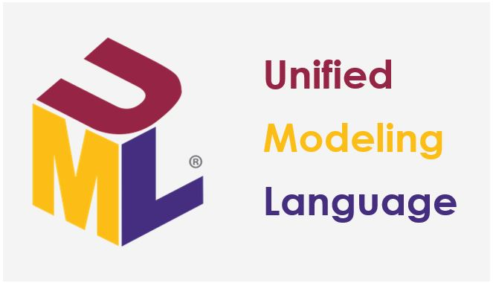
Figure 2-6: UML (Unified Modeling Language)

Chapter 3 Methodology

3.1 Introduction
The main goal of this chapter is to show us the stages of methodology to achieve our goal. That is, from the beginning of the project until the end, the software development life cycle (SDLC) of an application and model.
There are several models, such as (the speed improvement model, Evolutionary model, and waterfall model) to carry out a project. However, in our case, we will only be interested in the prototype model.

3.2 Methodology
We use a prototyping model for overseas education schools to make the system robust. We have chosen the Prototyping model to construct a characteristic quickly, however incomplete, a mannequin of the statistics system. There are numerous prototypes; however, they all intend to limit danger by constructing a rapid and soiled reproduction or mockup of the intended system. It can show technical feasibility when the technical threat is high. It can additionally be used to recognize higher and elicit consumer requirements. In both cases, the intention is to minimize danger and restriction charges with a growing grasp of proposed options before committing more significant resources.
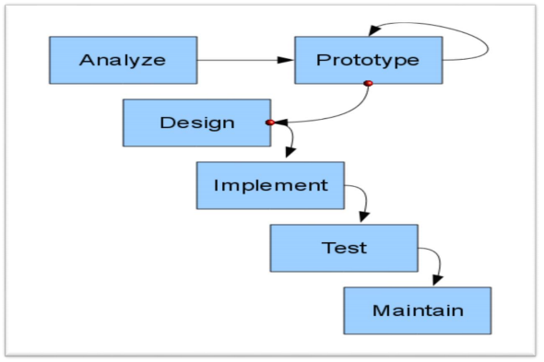
Figure 3-1 Prototype Model Steps

3.3 Prototype Model

3.3.1 Importance of Prototyping model
The importance of prototyping model are as follows:
(1) Reduces improvement time.
(2) Reduces improvement costs.
(3) Requires personal involvement.
(4) Consumers easily hold quantifiable feedback from developers.
(5) Make the implementation easy; the customer already understands the system.
(6) The owner is always satisfied.
(7) Detect future Improvement and enable their realization.

3.3.2 The steps of Prototyping model
The steps of prototyping model are as follows:
(1) Identify simple requirements; Determine simple necessities containing the inputs and outputs of information; the security detail can be ignored.
(2) Develop preliminary prototype; This part is implemented and consists of only person interfaces.
(3) Review; The customers and end-users, look at the prototype and provide remarks on additions or modifications.
(4) Review and improve the prototype; The opinion of customers, programmers, and their critics will make it possible to set up an excellent system to satisfy the customer.

3.4 Why using this prototype model:
The reason for using this prototype model is as follows:
(1) We always need user opinions about the system.
(2) With this methodology, the client already understands the system even before the finalization of the project.
(3) We can find errors and solve them earlier.
(4) Quicker personal remarks are handy to higher solutions.
(5) Missing performance can be recognized easily.
(6) Confusing or complex features can be recognized as necessities validation, speedy implementation of incomplete, but useful utility

3.5 The steps in Prototype Model

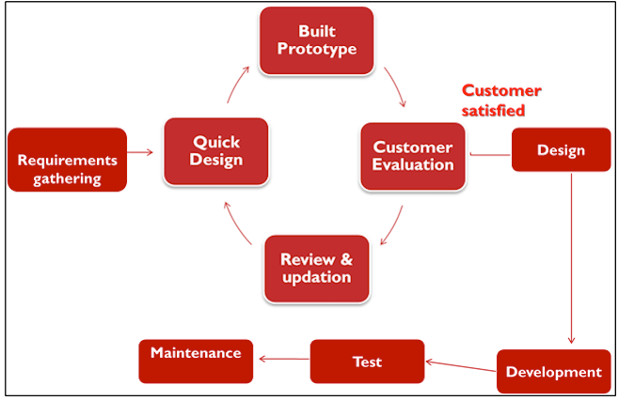
Figure 3-2 Prototype Model Steps
There are 4 phases to be done.
Step 1: First, know the most crucial system needs but also the inputs and outputs of the information.
Step2: In this Phase, we need U.I. (User interface) screens.
Step 3: This part concerns the finished product, the end customer, and having an eye on the prototype once provided in case of a problem to improve it.
Step 4: We need customer options after testing the prototype; it is reliable and meets his needs to return.

Chapter 4 Requirement Analysis

4.1 Introduction
This part explains how the overseas education school system work, starting from the devices and the users. It helps us to understand the functional and non-functional. Our system uses case, sequence, and activity diagrams to be more specific and understandable.

4.2 System Description
The Overseas education school (OESMS) is a Windows (desktop) Application that helps the administration, student, instructor, department, course, and enrollment; the primary goal of the system is to avoid using paper to collect and store the information but by using the system and for school administration to save money because each year the administration spends much money for the paper to collect the information, the students can know where their building is located by name.

4.3 User Description
The description of the user can be shown in Table 4-1.
Table 4-1 User Descriptions
ACTORS | FUNCTIONS
ADMIN(Head teacher) | login/logout  - Add New Students  - Add New Instructors  - Add New Department  - Add New Courses  -Add New Enrollments  - Edit Students  - Edit Instructors  - Edit Departments  - Edit Courses  - Edit Enrollments  - Delete Students  - Delete Instructors  - Delete Departments  - Delete Courses  - Delete Enrollments  - Clear Students  - Clear Instructors  - Clear Departments  - Clear Courses  - Clear Enrollments  -Print Students  -Print Instructors  -Print Departments  -Print Courses  -Print Enrollments
STUDENTS
INSTRUCTORS
DEPARTMENTS
COURSES
ENROLLMENTS

4.4 System Requirement
For the creation of any software, we need to know in which domain we want to realize our system in order to make an exemplary implementation through the design of the colors of the company for which we want to make the implementation. The forms, the color, and the design must reflect the institution and allow the system to be easy for the users.

4.4.1 Functional Requirement

4.4.1.1 Admin (Head teacher)
The Admin can realize the following functions.
(1) Add, edit, delete and print student.
(2) Add, edit, delete and print instructor.
(3) Add, edit, delete and print department.
(4) Add, edit, delete and print course.
(5) Add, edit, delete and print enrollment.

4.4.2 Non-Functional Requirement

4.4.2.1 Security
As a Desktop application, only Admin (Head teacher) has authorized users can access and complete control of the Application. The system is secure with a username and password given by the programmer or administrator (Head teacher). The passwords are encrypted.

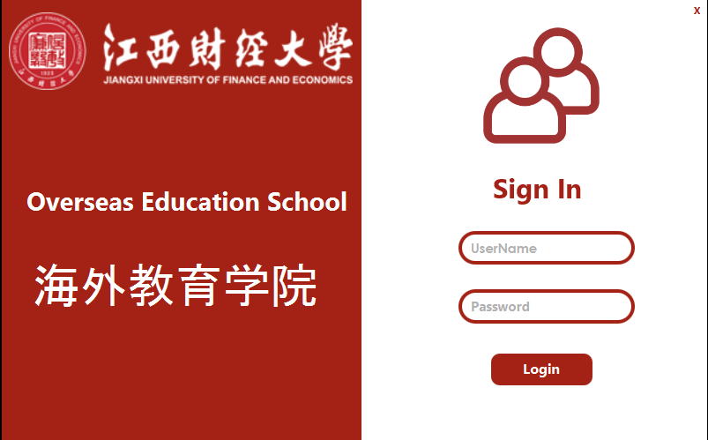
Figure 4-1 User Login Interface

4.4.2.2 Performance
It is easier for the tracking of records and updating can be fixed.

4.4.2.3 Availability
The system is always available anytime; you need a P.C. (Personal Computer) and do not need any Internet connection.

4.4.2.4 User Friendly
The user can easily use the system, which is friendly and understandable.

4.5 System Analysis
It evaluates the practical and non-functional necessities, use-case diagrams, and use-cases explanation. In addition, the interactive conduct of the things to do is analyzed through sequence and activity diagrams.

4.5.1 User Case Diagram
User case diagrams allow us to understand the system case by case, from the beginning system to the end user; with a user diagram, the system is evident through the different actors who participate in the system's functioning.
Admin (head teacher) can do the functions after login, as shown in Figure 4-2.
(1) Add Instructors, including (Edit/Print/Delete).
(2) Add Students, including (Edit/Print/Delete).
(3) Add departments, including (Edit/Print/Delete).
(4) Add enrollments, including (Edit/Print/Delete).
(5) Add Courses, including (Edit/Print/Delete).

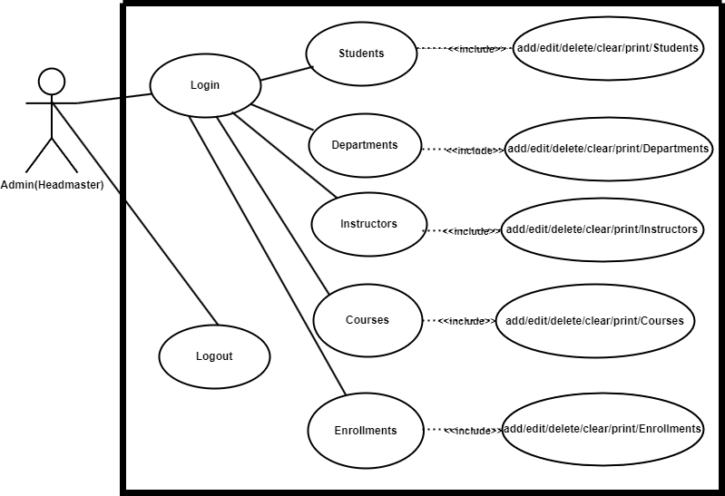
Figure 4-2 User Case Diagram

4.5.2 Sequence Diagram
The sequence diagram is focused on communication between the user and the system through the exchange of messages, each response in turn. He details the different sequences in the system.

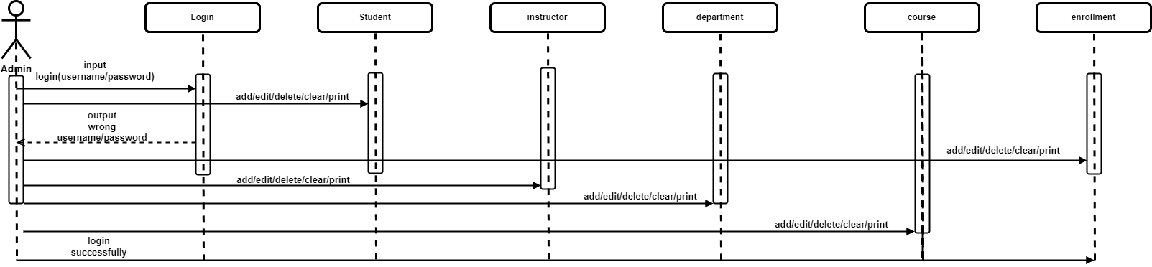

Figure 4-3 Sequence Diagram
4.5.3 Activity Diagram
Activity diagrams explain to us precisely the active part of our system.
The activity diagram is shown in Figure 4-4.

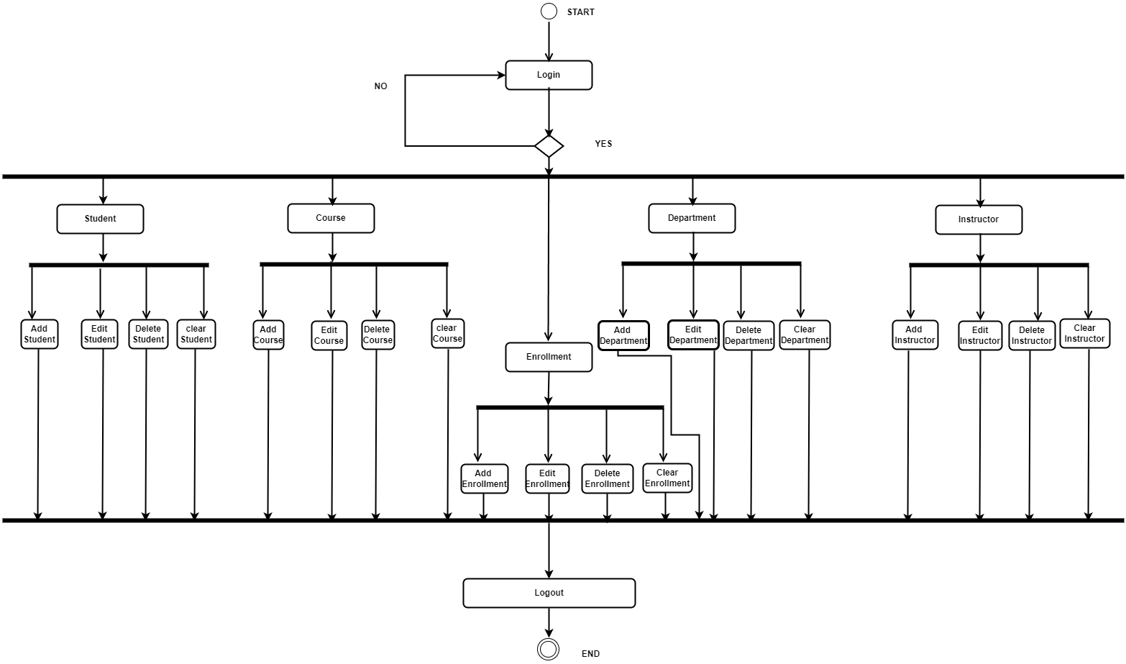
Figure 4-4 Activity Diagram

Chapter 5 Design and Implementation

5.1 Analyze Phase
We help overseas education schools determine the project's requirements and explain how we can improve their performance and satisfy the school by implementing a sound system.

5.2 Build A software
Here we introduced the software’s used to describe our system.

5.2.1 Programming Tools
The software uses desktop application principal with JavaFx framework, scene builder as G.U.I. (Graphical User Interface) drag and drop and FXML user interface markup language visible by the user front end (View). For the back end, the software is implemented using JavaFX (Model and Controller), where the class and methods are visible to make the software dynamic.
(1) Allow the software easy to useable for the user.
(2) Allow the software to be understandable.
(3) Designing the software according to school requirement
Then, make the software dynamic using programming tools such as JavaFx framework and MySQL DBMS (Database Management System) that help users to store information and be visible.

5.3 Design Phase
According to the class diagram of the school and entities and relationship diagram, we can design this Phase easily. And mapping in the relational database management system of our entities and relationship.

5.3.1 Class Diagram
The class diagram of the system contains the class name, attributes or properties, and method; these class diagrams are communicated with the controller and model in the system.
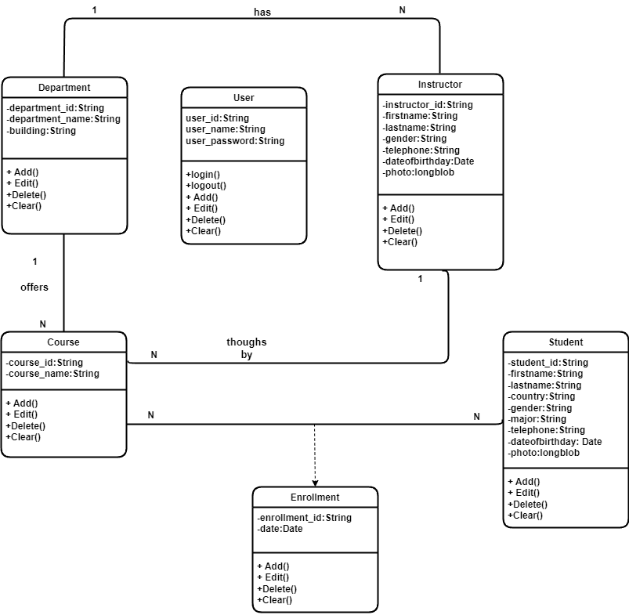

Figure 5-1 Class Diagram

5.3.2 Database Schema
The representation of the entities and relationships in RDBMS (Relational Database Management System) MySQL represents the physical view; it shows us how the tables are organized and the relationships among them are associated. We can see the foreign key and primary key in the tables. The system has six tables in the database.
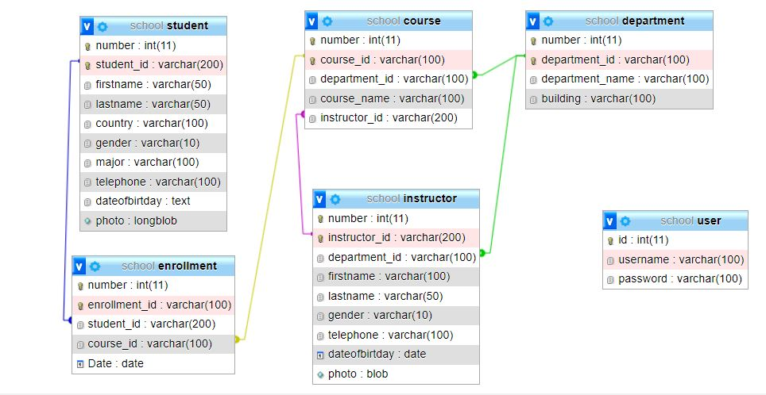
Figure 5-2 Database Schema

5.3.3 Entity Relationship Diagram (E.R.D.)

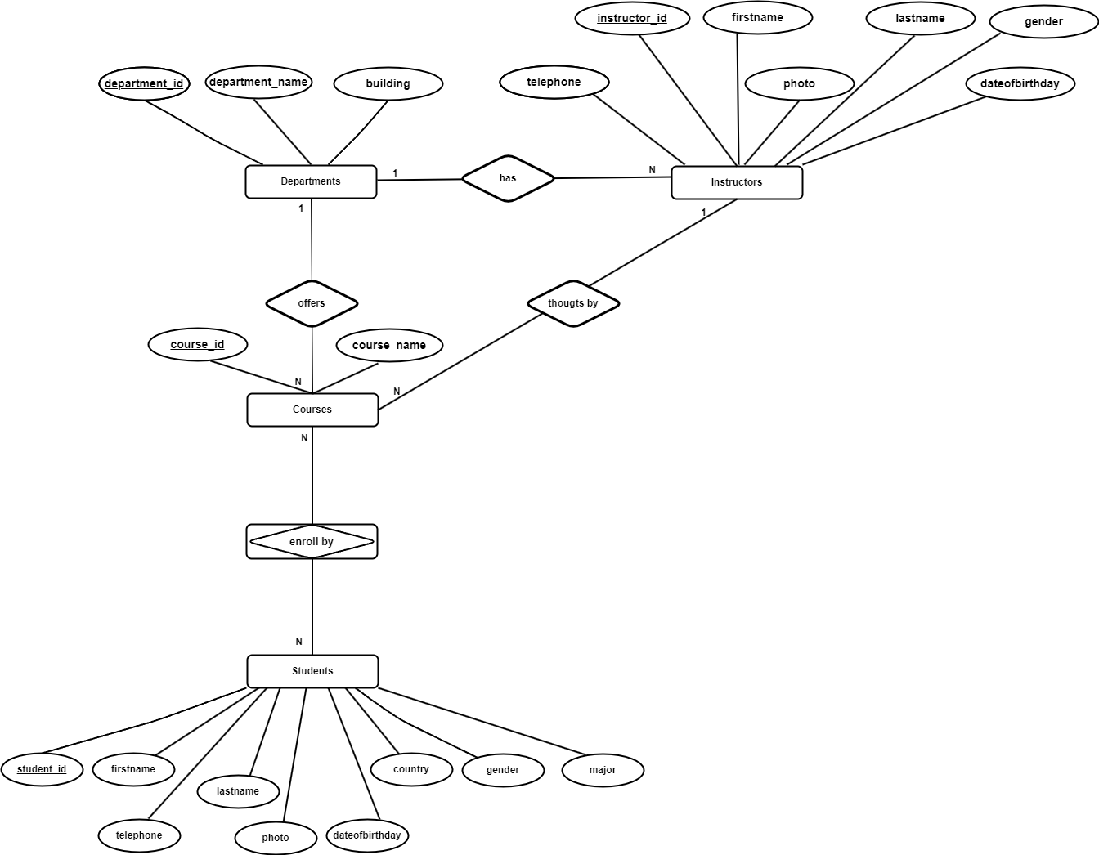

Figure 5-3 Entity Relationship Diagram (E.R.D.)

5.4 Implementation Phase
After developing the databases using the entity and relationship diagram of the software, to realize this Phase, we are using MVC (Model View Controller) architecture and techniques used to develop the desktop App, and the implementation starts with.
Implementation of connection class to know if the software and MySQL RDBMS can communicate using API (Application Programming Interface) as JDBC (Java Database Connectivity), the model that contains the class (attributes, constructor, get and set), controller (methods, add, delete, edit clear, print) for the source code, and view (FXML file) for the user.

5.4.1 Design:

5.4.1.1 Admin (Head teacher) G.U.I.
Graphical User Interface. Here is a given front page of the Application, where the user (head teacher) can log in with their username, id, and password.

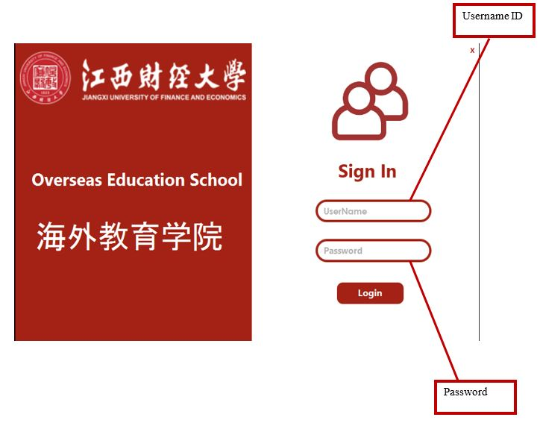
Figure 5-4 Admin Interface

5.4.1.2 Home Page
Graphical User Interface for the home page. Here is a given home page of the Application, where the user (head teacher) can visit the home page form and has complete control of the system. Once the username and password are correct, the head teacher can access the home page.

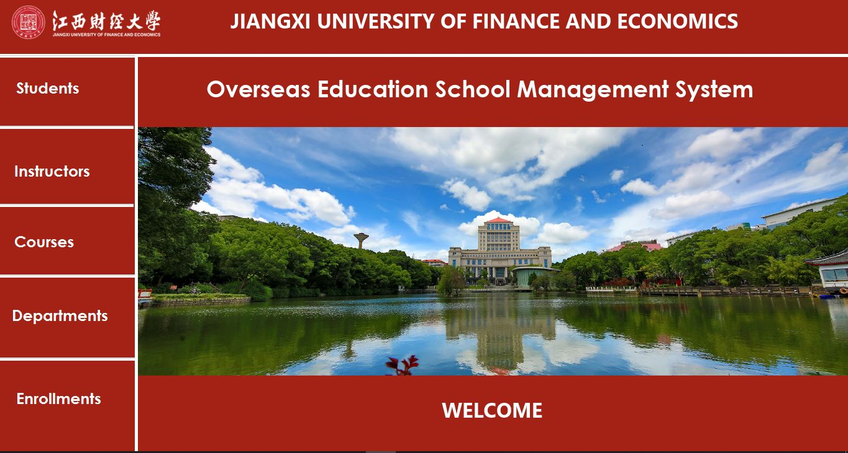
Figure 5-5 Home Interface

5.4.1.3 Students Interface
Graphical User Interface for student page. Here is a given student page form of the Application.
Log in as a head teacher and visit the student page form by clicking on the button student and filling in the fields (ID, First Name, Last Name, Gender, Major, Telephone, D.O.B., Country, Photo)
- Click Add button to add student information to the table and database.
- Click the Edit button to modify student information in the table and database.
- Click the Delete button to delete student information in the table and database.
- Click the Clear button to clear student information in the fields.
- Click the Print button to print student information from the table and database.
- Research student by (ID, First Name, Last Name)

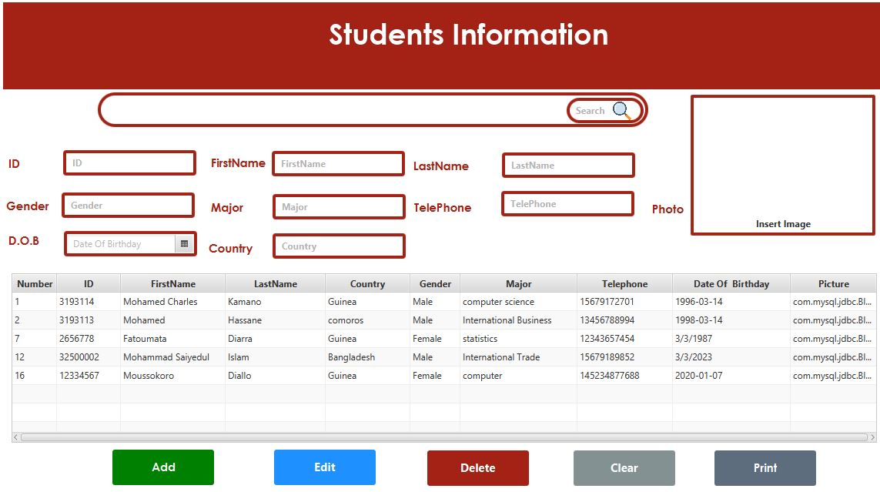
Figure 5-6 Student Interface

5.4.1.4 Instructor Interface
Graphical User Interface for instructor page. Here is a given instructor page form of the Application, where the user (head teacher) can visit the instructor page form and fill it.
Log in as a head teacher and visit the instructor page form by clicking on the button Instructor and fill in the fields (ID, First Name, Last Name, Gender, Telephone, D.O.B., Department Name, Photo)
- Click Add button to add instructor information to the table and database.
- Click the Edit button to modify instructor information in the table and database.
- Click the Delete button to delete instructor information in the table and database.
- Click the Clear button to clear instructor information in the fields.
- Click the Print button to print instructor information from the table and database.
- Research instructor by (ID, First Name, Last Name)

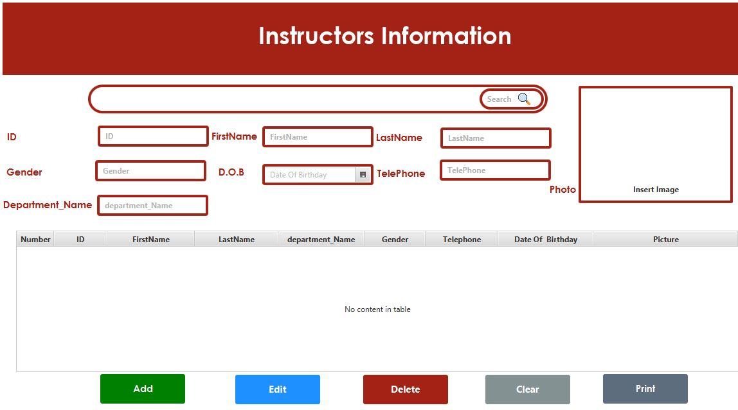
Figure 5-7 Instructor Interface

5.4.1.5 Courses Interface
Graphical User Interface for the course page. Here is a given course page form of the Application, where the user (head teacher) can visit the course page form and fill it.
Log in as a head teacher and visit the course page form by clicking the course button and filling in the fields.
(I.D., Course Name, Department Name, Instructor ID)
- Click Add button to add instructor information to the table and database.
- Click the Edit button to modify instructor information in the table and database.
- Click the Delete button to delete instructor information in the table and database.
- Click the Clear button to clear instructor information in the fields.
- Click the Print button to print instructor information from the table and database.
- Research course by (I.D., Course Name, Instructor ID)

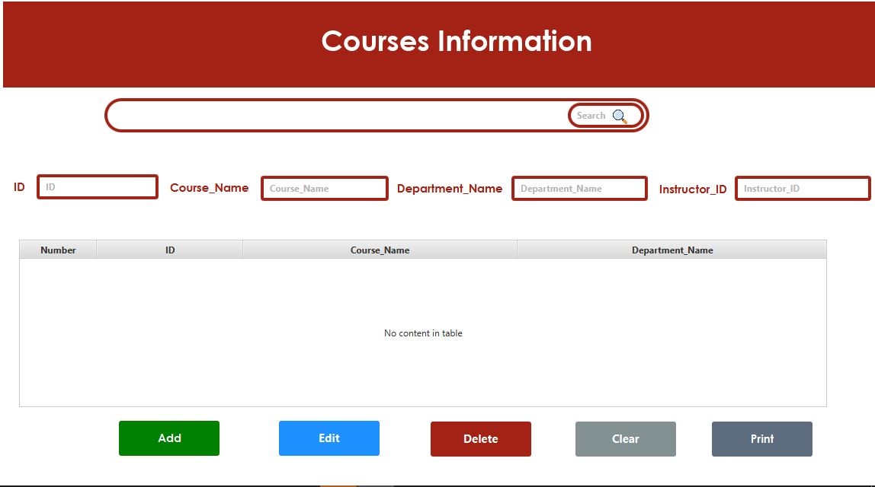
Figure 5-8 Course Interface

5.4.1.6 Departments Interface
Graphical User Interface for department page. Here is a given department page form of the Application, where the user (head teacher) can visit the department page form and fill it.
Log in as a headteacher, visit the course page form by clicking the course button, and fill in the fields (I.D., Department Name, Building)
- Click Add button to add department information to the table and database.
- Click the Edit button to modify department information in the table and database.
- Click the Delete button to delete department information in the table and database.
- Click the Clear button to clear department information in the fields.
- Click the Print button to print department information from the table and database.
- Research department by (I.D., Department Name, Building)

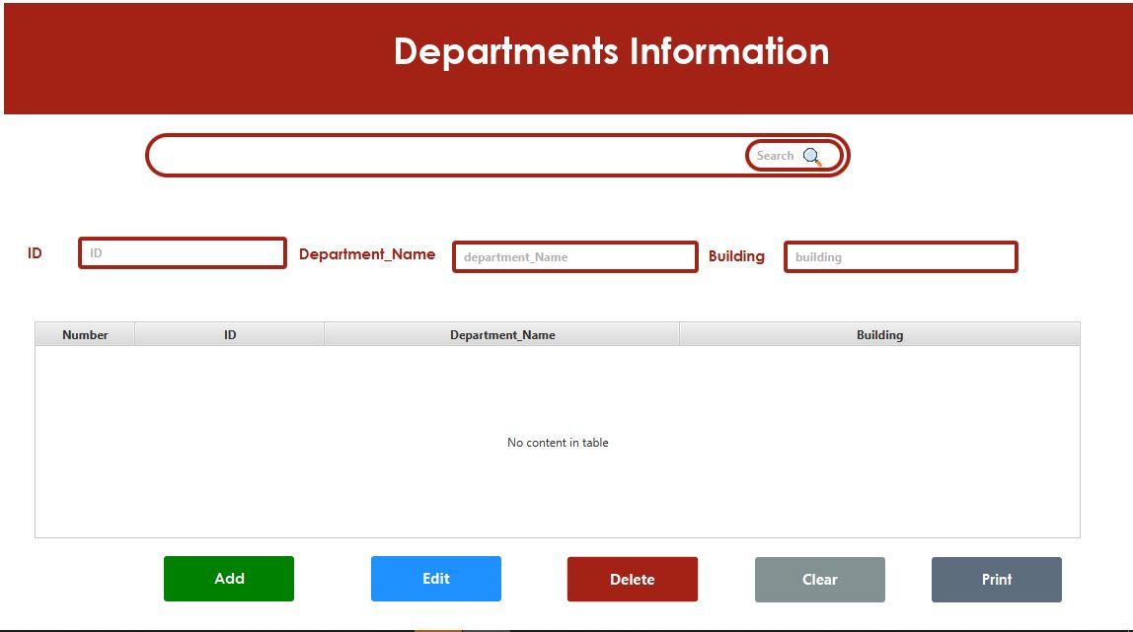
Figure 5-9 Departments Interface

5.4.1.7 Enrollments Interface
Graphical User Interface for Enrollment page. Here is a given enrollment page form of the Application, where the user (head teacher) can visit the enrollment page form and fill it.
Log in as a headteacher, visit the course page form by clicking on the button enrollment, and fill in the fields (I.D., Student ID, Course ID, Date)
- Click Add button to add enrollment information to the table and database.
- Click the Edit button to modify enrollment information in the table and database.
- Click the Delete button to delete enrollment information in the table and database.
- Click the Clear button to clear enrollment information in the fields.
- Click the Print button to print enrollment information from the table and database.
- Research department by (I.D., Student ID, Course ID)

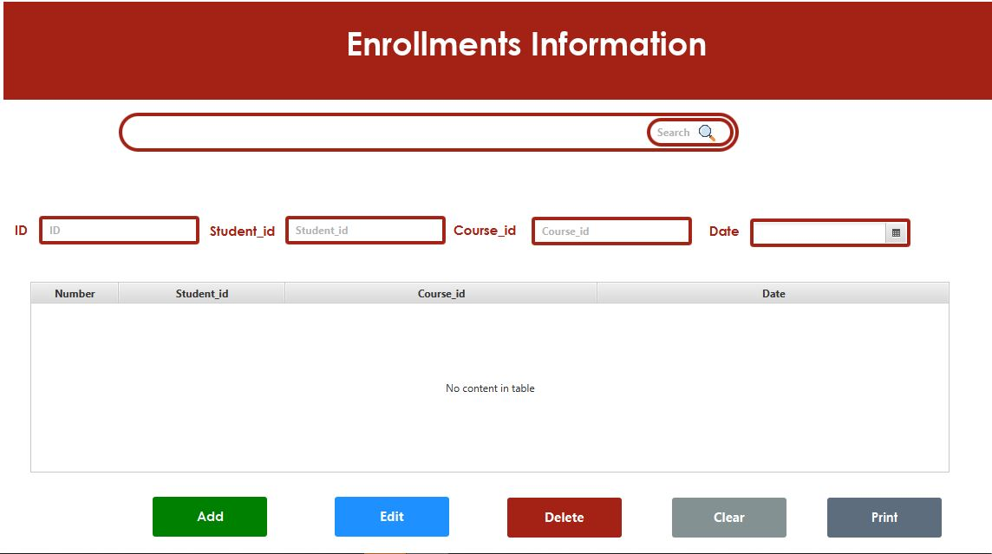
Figure 5-10 Enrollments Interface

Chapter 6 Source Code

6.1 JavaFx Main Class
Generally, a JavaFX application has three major components: Stage, Scene, and Nodes, as shown in the following source code.
Stage: A stage (a window) contains all the objects of a JavaFX application. The Stage class of the package javafx represents it. Stage. The platform itself creates the primary stage. The created stage object is passed as an argument to the start () method of the Application class (explained in the next section).
A stage has two parameters determining its position, namely Width, and Height. It is divided into Content Area and Decorations (Title Bar and Borders).
There are five types of stages available:
- Decorated
- Undecorated
- Transparent
- Unified
- Utility
You must call the show () method to display the contents of a stage.
Scene Graph and Nodes: A scene graph is a tree-like data structure (hierarchical) representing the contents of a scene. In contrast, a node is a visual/graphical object of a scene graph.
A node may include:
- Geometrical (Graphical) objects (2D and 3D) such as circles, rectangles, and polygons.
- U.I. Controls such as buttons, Checkbox, Choice Box, and Text Area.
- Containers (Layout Panes) such as Border Pane, Grid Pane, and Flow Pane.
- Media elements such as Audio, Video, and Image Objects.
A JavaFX scene is represented by the Scene class of the package javafx. scene. You can create a Scene by instantiating this class as shown in the following source code.

The Application class of the package javafx. Application is the starting point of the Application in JavaFX. To create a JavaFX application, you must inherit this class and implement its abstract method start (). In this method, you must write the entire JavaFX graphics code.
You must launch the Application using the launch () method in the primary method. This method internally calls the start () method of the Application class, as shown in the following program. Without this primary method (source code) of JavaFx, we cannot launch the Application.

#insert core code in text

Figure 6-1 JavaFx Main Class method source code

6.2 Main Connection Class to the Database
The main goal of this method (source code) is how to link desktop Applications to the DBMS (Database Management System) by using an API (Application Programming Interface) JDBC (Java Database Connectivity).

#insert core code in text

Figure 6-2 Connection to Database method source code

6.3 Method to filter table research
To search for someone or something in the system, we need to implement this method (source code) to help the headteacher to find someone or something quickly by id or name.

#insert core code in text

Figure 6-3 Method of filtering table

6.4 Home Page
The main goal of this method (source code) is to show all forms once the username and password are correct on the page; then, we can visit any form by clicking on the button.

#insert core code in text

Figure 6-4 Method to show the page of course

#insert core code in text

Figure 6-5 Method to show the page of the enrollment

#insert core code in text

Figure 6-6 Method to show the page of the instructor

#insert core code in text

Figure 6-7 Method to show the page of the student

Chapter 7 Conclusion and Future Work

7.1 Conclusion
The growing use of digital technology in education will necessitate significant changes in educational institutions' operations in the coming years. Rather than a fad, this will be a long-term strategy in the new reality that will shape history. To put the school management system on the map and into the competition, we must have a robust solution to fill the school's needs. The system developed in the project consists of Windows (desktop) Applications. The Windows application takes most activities such as offline student registration, department, instructor, course, and enrollment.
In the 21st first century, we cannot do anything without technology. Technology changes our life in all aspects, and people are becoming increasingly interested in these changes. Therefore, this demand for education applications is very high. The overseas education school management system will help the school manage the different school services to make their work easier.

7.2 Future Work
We have listed some recommendations and future works to enhance the system's efficiency in the following.
As education is central to development, an excellent facility for administration and instructors to participate in school improvement programs and decision-making should be provided. Instructors and Education Bureaus are among the stakeholders.
Moreover, in the future, this system can be extended to several parts, such as:
- Making the system windows(desktop) and web application to allow all Users to enter the system, printing student and instructor cards.
- The system will allow students to pay he/she school fees online and receive an electronic receipt.
- The parents will see the student's mark in each class and the result after a year and can communicate with the school to know how their kids are.
- The system will manage student rooms in the future; it will be able to inform if the room is single or double but also inform when it is occupied by a student or not.
- Will able to generate time table automatically to help students and department
- The student will be able to know their information but also check he/she performance online.

References
[1] https://www.studocu.com/in/document/gujarat-university/m-sc/84656452-dsfsdfsdfsd/30794142
[2] https://openjfx.io/
[3] Chakraborty N R, Latif S, Islam Y M. Requirement Elicitation: A" Live" Prototyping Approach[J]. International Journal of Computer Applications, 2013, 72(13).
[4] Thomas, D. The Pragmatic Programmer: From Journeyman to Master[M], 1st Edition,2003.
[5] https://docs.oracle.com/javase/8/javafx/api/javafx/scene/doc-files/cssref.html
[6] https://www.tutorialspoint.com/how-to-implement-actionevent-using-method-reference-in-javafx
[7] https://www.flexganttfx.com/?gclid=Cj0KCQiA6fafBhC1ARIsAIJjL8mxy0yPHmSHwRjAPVE-whfbe5zuc55HY0rE2iCUt_C4fOQ6O0oO4X0aAu8yEALw_wcB
[8] Bagui S., Richard E. Database Design Using Entity-Relationship Diagrams Foundations of Database Design English[M], 2011.
[9] http://docs.oracle.com/javafx/2/overview/jfxpub-overview.htm, [Accessed: 27 Apr 2017].
[10] https://www.codejava.net/frameworks/spring/install-spring-tool-suite-windows
[11] Duckett, J. Web Design with HTML, CSS, JavaScript and jQuery Set [M], 1st Edition,2014.
[12] Luke Welling, L. T. PHP and MySQL Web Development (4th Edition) [M], 4th Edition, 2003.
[13] J. G. Hedberg et al. Educational information systems: Problems of the small educational organization[J]. Australian Journal of Educational Technology, 1992, 8(2), 132-160.
[14] http://codecanyon.net/item/ekattor-school-managementsystem-pro/6087521
[15] http://www.slideshare.net/aki_string/schoolmanagement-system-21413550
[16] http://readyset.tigris.org/
[17] S. Petrovic and E. Burke. University Timetabling, School of Computer Science and Information Technology, University of Nottingham, 2002, 1-4
[18] R.J. Willemen. School Timetable Construction: Algorithms and Complexity[D], Faculty of Mathematics and Computer Science, Technische Universiteit Eindhoven, 2002.
[19] Armstrong, B., Fogarty, G., & Dingsdag, D. Validation of a Computer User Satisfaction Questionnaire to measure I.S. success in small Business [J]. Journal of Research and Practice in Information Technology, 2005, 37(1), 27 – 42.,
[20] DeLone, W. H., & McLean, E. R. Information System success: The quest for the dependent variable[J]. Information System Research, 1992, 3(1), 36.
[21] DeLone, W. H., & McLean, E. R. The DeLone and McLean Model of Information System Success: A ten-year update[J]. Journal of Management Information Science, 2003, 19(4), 9-30.
[22] McGill, T., Hobbs, V. & Klobas, J. User-development applications, and information system success: A test of DeLone and McLean's Model[J]. Information Resources Management Journal, 2003, 16(1), 24-45.
[23] Iivari, J. An empirical test of the DeLone-McLean model of information system success[J]. DATABASE, 2005, 36(2), 8-27.
[24] Goodhue, D. L., & Thomson, R. L. Task-technology fit and individual performance[J]. M.I.S. Quarterly, 1995, 19(2), 213-236.
[25] https://www.kashipara.com/asset/pdf/report-sample/kashipara.com_School-Management-System-Project-Documentation.pdf
[26] Abu-Duhou, I. (1999). School-based management: Fundamentals of educational planning. Paris: UNESCO/ Internationality Institute for Educational Planning
[27] Murphy, J. & Beak, L. G. (1995). School management as school reform: Taking Stock, pp.20-60; California: Corwin.
[28] Glewwe, P., Kremer, M., 2006. Schools, teachers, and education outcomes in developing countries. In: Handbook of the Economics of Education Elsevier (Chapter 16)
[29] Bober, M. (2001). School information systems and their effect on school operations and culture. Journal of Research on Technology in Education, 33 (5), 1–11.
[30] Demir, K. (2006). School management information systems in primary schools. The Turkish Online Journal of Educational Technology, 5 (2), 32–45.
[31] https://www.tutorialspoint.com/javafx/javafx_application.htm.

